Manaslu Tsum Valley Trek

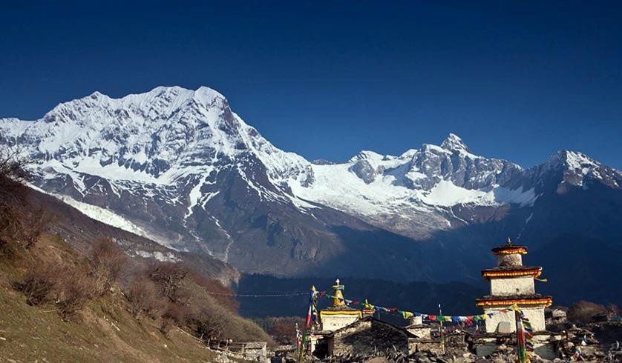

**Trek Introduction**

**Manaslu Tsum Valley Trek** provides us with a wonderful opportunity to escape ourselves through daily routine and completely immerse in natural beauty around 8th highest Manaslu Himalayas with cultural exploration at hidden valley of Tsum. With less than decade of its opening to outsiders, Tsum valley has been successfully able to enchant the visitors with its diversity in topography and richness in Tibetan influenced cultures and traditions.

We embark for **Manaslu Tsum Valley Trek** as you arrive at Kathmandu and complete sightseeing around world heritage sites. During the beginning of Manaslu Tsum Valley Trek, we take a drive to Baseri, which is the starting point of this trip. We pass through exceptionally beautiful, and naturally blessed Budhi Gandaki valley. Trekking along the way through beautiful forests, farmlands, pastures, settlements, and villages of mostly Gurungs and Magars; we enter the hidden Tsum valley leaving back the Manaslu Trail. Tsum valley is popular for outstanding views of Himalayan ranges like Ganesh Himal and Manaslu etc. Along the way, we pass through numerous Buddhist monasteries watching the Tibetan influenced cultures. Tsum valley also offers insights into lifestyle of tribes living there which will surely be a cultural shock to

outsiders. **Manaslu and Tsum valley** is well known home stay trek, but in the present scenario plenty of tea houses also have developed around the trails. During the final days of the trek, we again caught up with the popular circuit route of Tal, Syange and drive back to Kathmandu.

**Proposed Itinerary**

Day 01: Arrival Kathmandu Met and transferred to your hotel (B)

Day 02: Kathmandu sightseeing ½ day (Pasupatinath temple, Buddha nath) and trekking preparation one full working day. Overnight at hotel.

Day 03: Kathmandu - Arughaat - Jagat. by private jeep (1,060m/3,477ft.) drive 6-7 hours overnight at lodge. (BLD)

Day 04: Jagat to Lokpa (1,960m/6,430ft.) 6-7 hours overnight at lodge (BLD) Day 05: Lokpa to Chumling (2,386m/7,636ft.) 4 hours overnight at lodge (BLD)

Day 6: Chumling to Chhokang Paro (3,031m/9,944ft.) 5 -6 hours overnight at lodge (BLD)

Day 7: Chhokang Paro to Mu Gompa (3,709m/12,168ft.) 4-5 hours overnight at monastery lodge (BLD)

Day 8: Mu Gompa Explore day (BLD)

Day 9: Mu Gompa to Chhokang Paro (3,031m/9,944ft.) on the way back visit monastery and have lunch in Lama goum then back to Chhokang paro 7 hours overnight at lodge (BLD)

Day 10: Chhokang Paro to Lokpa (1,960m/6,430ft.) 6-7 hours overnight at lodge (BLD) Day 11: Lokpa to Deng (1,860m/6,102ft.) 5-6 hours overnight at lodge (BLD)

Day 12: Deng to Namrung (2,630m/8,628ft.) 7-8 hours overnight at lodge (BLD) Day 13: Nameung to Lho (3,180m/10,433ft.) 4 hours overnight at lodge (BLD) Day 14: Lho to Samagaon (3,520m/11,548ft.) 5 hours overnight at lodge (BLD) Day 15: Samagaon day hiking explore monastery or lake (BLD)

Day 16: Samagaon to Samdo (3,875m/12,713ft.) 4 hours overnight at lodge (BLD) Day 17: Samdo to Dharamsala (4,460m/14,632ft.) 4 hours overnight at lodge (BLD)

Day 18: Dharamsala to Bhimtang (3,700m/12,139ft.) via Lark pass (5,160m/16,924ft.) 8-9 hours overnight at lodge. (BLD)

Day 19: Bhimtang to Gho (2,515m/8,251ft.) 5-6 hours overnight at lodge (BLD) Day 20: Gho to Tal (1,710m/5,610ft.) 6 hours overnight at lodge (BLD)

Day 21: Tal to Besishar local jeep and Besishar and Kathmandu by car (B)

Day 22: Departure to own destination (Try and book an evening flight as this will give you all day in Kathmandu.

Price per- person $5500 per person ( full board package) Price Includes

* Airport pickup and drop service
* All food and lodging during the trek (B,L,D included)
* Transportation costs: Comfortable Drive from Kathmandu to start of trek and from Tal to Kathmandu by jeep and private car.
* Professionally trained and highly experienced English speaking trekking guide and a porter (1 porter for 2 trekkers with max load of 30kg) along with their salary, lodging, food and insurance
* Trekking permits: Manaslu Conservation Area fees, Manasalu special permit, Tsum valley special permits , Annapurna conversation area permits and TIMS Card
* Kathmandu sightseeing with Car and guide
* During trekking accommodation
* First aid medical box
* All required trekking gears like sleeping bag and down jacket made available on rent
* 13% VAT and 10% company service charge
* Farewell Dinner
* Kathmandu hotel accommodation including breakfast Price Excludes
* Visa fee to enter Nepal
* International flight tickets and extra baggage charges
* Travel insurance/ Rescue operation costs
* All personal expenses
* Tip for guide and porter
* First aid medical box
* All required trekking gears like sleeping bag and down jacket made available on rent
* 13% VAT and 10% company service charge
* Farewell Dinner